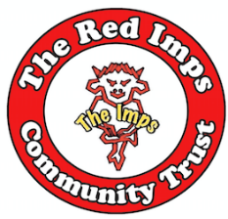

LINCOLN CITY SUPPORTERS SOCIETY LTD
“THE RED IMPS COMMUNITY TRUST”
MAIN SPONSOR - TENSION TWISTED REALITIES
^{13th} June 2022

Dear Trust Member
I write to inform you that the 2022 Annual General Meeting of Lincoln City Supporters Society Ltd will take place on Thursday 18 August 2022, commencing at 7.30pm.
The meeting will be virtual and restricted to 100 members.
Members of the Trust who wish to take part in the AGM must apply to do so via email to media@redimpstrust.co.uk no later than 11 August 2022.
There are vacancies for Trust Board Directors as well as for the position of Supporter Director which becomes vacant by rotation. All paperwork required should you wish to stand is available on the Trust Website – www.redimpstrust.co.uk/agm2022.
The scanned nomination forms must be returned by 12 noon, Monday 1 August 2022 to the email address media@redimpstrust.co.uk.
An official notice convening the meeting together with associated documentation will be sent to you once the closing date for nominations for the above positions has passed.
If you have any questions, please do not hesitate to contact me at the email address above.
Yours sincerely
S.M. Freestone
Secretary | Lincoln City Supporters Society Ltd (Trading as Red Imps Community Trust)
Lincoln City Supporters Society Ltd
www.redimpstrust.co.uk

